January 2017 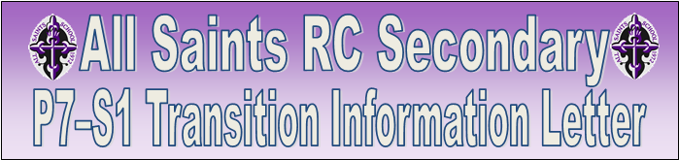 September 2016

Dear Parent/Carer

I will be co-ordinating the transition from our associated Primary Schools to All Saints for the 2017-18 session.

We are all looking forward to welcoming your children to All Saints RC Secondary in August 2017.

We have already met with the Primary Head Teachers of St Catherine’s, St Martha’s, St Philomena’s and St Monica’s and our full transition programme is about to begin.

For those learners who require additional support in school, our Pupil Support Team are carefully planning with our Primary colleagues through enhanced transition meetings.

Key elements of our very effective transition programme will be:

First year learner’s will visit Primary 7 with myself to present “Life in All Saints” this month.

P7 will visit All Saints with final dates tbc:
day 1 – 17th February 2017
day 2 – April 2017 (tbc)
day 3 – June 2017(tbc)

If you have any issues or concerns regarding your child’s transition from Primary to Secondary School, please do not hesitate to contact me at All Saints RC Secondary.

Yours sincerely

J Houston
S1 Depute Head Teacher

Uniform
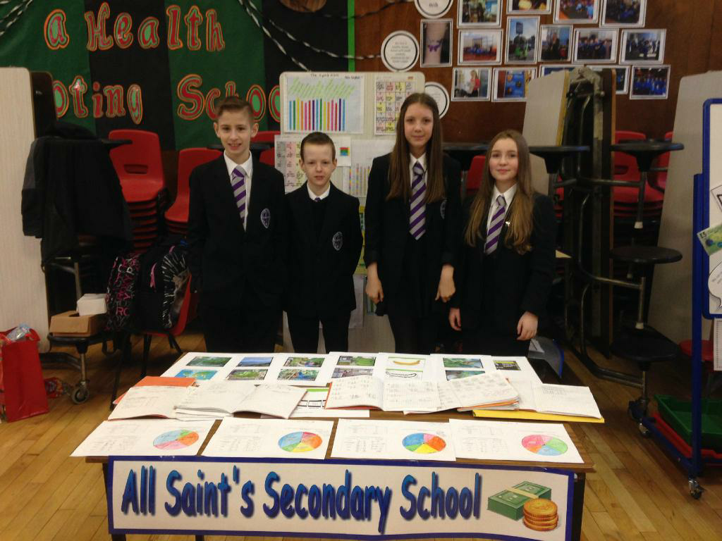
Our young people are showing impressive commitment to their school uniform.
Visitors to our school always comment on the impressive appearance and good manners of the young people here and our learners tell us about the sense of pride they feel as they wear their school uniform.
Just as a reminder, our uniform is:
School Blazer
White shirt & school tie
Black trousers or skirt
All black footwear

There will be a blazer fitting during the June visit.

Welcome to S1 - Here are some messages from our current S1 Learners

Staff Mr Houston will be your Head of Year and Miss Goldie will be Pupil Support.

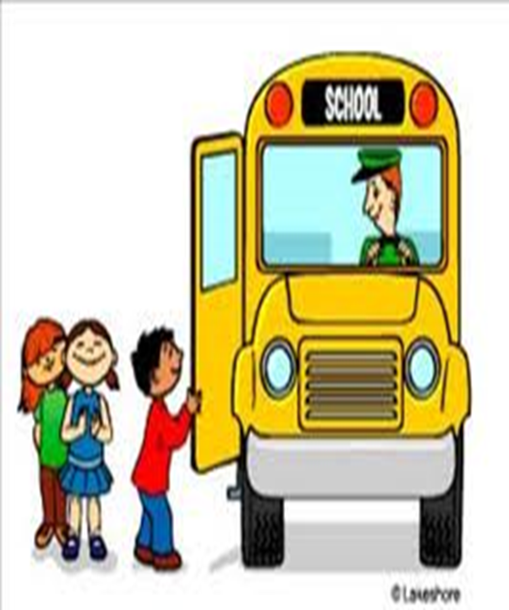
Travelling to and from Milton
There are three buses available.
Friendly environment.
The late bus is an hour after school day to let you go to after school classes and clubs.
Safe –lots of seats with seatbelts.

1st Year Yard
The first year yard is a place where you can sit with your friends and not get annoyed by the rest of the older
learners.
Fuel Zone
The Fuel Zone sells pizzas, calzones, burgers, rolls and spaghetti Bolognese for example.
There is a Snack Bar, called the HUT, in the first year yard, especially for us.

Netball and Football teams
After school only.
Get to go to different schools across the city.
Lots of fun.
Good achievements.
Builds Team skills.
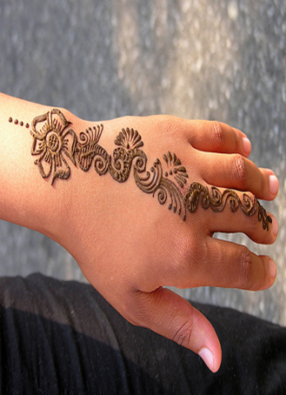
Activity Slot
Lots on offer every Monday afternoon.
Fun.
Different clubs like football, netball, knitting, gymnastics, henna, film club and drama.

Clubs
Stem (Science technical engineering maths)
Craft club.
Dodgeball.
Rugby.
Library sessions and lots more!

Bullying
At All Saints we have an anti-bullying policy and any form of bullying will not be tolerated.
Anyone who has experienced bullying has felt it has been dealt with appropriately and efficiently.

Achievements
There are multiple awards on offer in All Saints. Not long ago we did netball, football and basketball tournaments. The winning teams received medals for their success.
Rewards; Scientist of the month, Maths award, Technical award and much more.

Follow us on Twitter Like us on Facebook
@AllSaintsRCSec @AllSaintsRCSecondary

