S3 Homework Booklet Tasks
When you see the following symbol below you are being asked to…
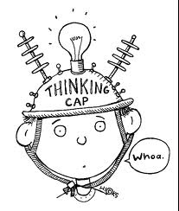
Think about/imagine! Look up….. Find out about/research Report back…..

- Community- Write a letter to your MP about 1 thing you would like to change in your area and why you feel this is important.
- Building Christian Community- Find out about Christian groups in your area. Write a newspaper report about the good work they are doing and the positive difference they make to the lives of others.

- 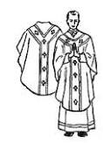Church Year- Design a “do’s and don’ts” booklet about the Church Year and colour of vestments (robes) the priest should wear. Eg Do wear red at Pentecost. Don’t wear white during Lent.

- Ways To Pray- Design a poster with a catchy slogan encouraging people to pray! Think about the reasons why we pray and how important prayer is.

- Meditation- Watch a you tube clip about meditation. Write a brief summary of what you see; eg how is the person sitting? What expression do they have on their face?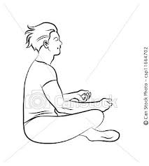
- T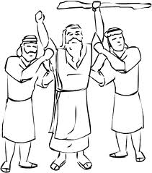The Prophet Amos- Find an article in the news today of someone who stood up against injustice. Think about how the person would have felt about standing up for what is right, what action they took and the possible CONSEQUENECES of doing the right thing!

- The Prophet Jeremiah- Design a face-book page for the Prophet Jeremiah, don’t forget a profile picture!

- 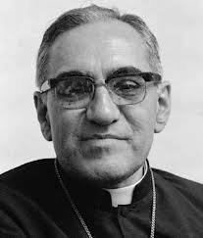 Prophets Today- Oscar Romero- Research- El Salvador where Oscar Romero was from. Write down 3 problems the country faced in Oscar Romero’s time and 3 problems it faces today.

- Oscar Romero- Imagine you are Oscar Romero. Write a secret radio broadcast encouraging people to have faith and to stand up against the government.

- Sermon on the Mount- Design a cartoon strip outlining what happened in the Sermon on the Mount. Include what the main message of Jesus’ speech was and what would be HARD to accept about it-the reaction of others.

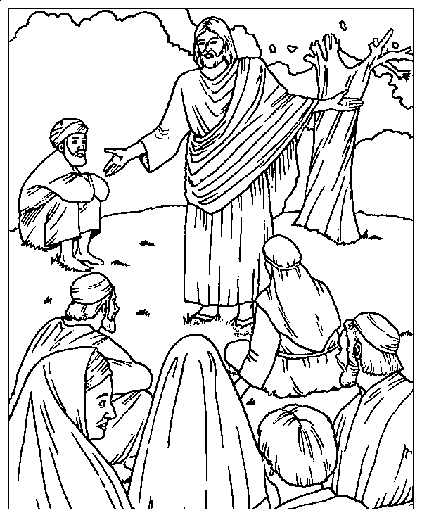
- Research Activity: Think about a programme on tv/ a film you have seen. Now select a quality from the list: bravery, forgiveness, caring, peaceful, gentleness, prayerful, respectful, fairness. Describe how this quality is shown in how this person acts/ treats others. Do you think it was easy/difficult for the character to behave as they did? Explain your answer.

- The Kingdom of God-Small thing’s can make a BIG difference!! Fill in the Kingdom shown with small thing’s we could all do each day that would make the world a better place; eg listening to someone’s problem, taking the dog out without having to be asked, being patient with a younger brother/sister

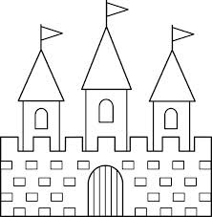

- Sacraments in the Orthodox Church- List 5 ways that the Orthodox Church is similar to the Catholic Church. List 5 ways that is DIFFERENT from the Orthodox Church.

- 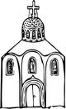Inside an Orthodox Church. Go online and do a virtual tour of an Orthodox Church. Choose from one of the following features inside it; an Icon, Altar, icon screen. Describe what the purpose of this feature is.
“I have a dream....”
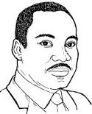

- Prejudice- Complete the following fact file on Martin Luther King:
Name:
Married or Single:
Children:
Religion:
Occupation:
Nationality:
Awards Received:
He believed in...
He died Where:
When:
How:
He is remembered today because:

- Search for Martin Luther King’s most famous speech; “I Have a Dream”. Watch it online (eg you tube) or read the transcript of it. Think! How do you think Martin Luther King felt when he wrote this speech? What was his dream for the future? Do you think his dream has come true today? Have these points ready to discuss in class.

- Stereotyping: Imagine you are a traveller. Write a postcard to a friend in a settled home about what you enjoy about your life. Say what you don’t enjoy, for example how some people stereotype you. Explain to your friend what kind of thing’s are untrue about your way of life and why this is unfair.

Discrimination- Research a case in the last few years where travellers have been discriminated against. Imagine your writing for a local paper. Write a short story on how the travellers were discriminated against ands why this is wrong.

- The Beginning of Islam: Summarise one thing that the Prophet Muhammad wanted to CHANGE in Mecca and why.

- Islam Today: Choose from one of the following: The Qur’an , The Mosque, Prayer. Design a bookmark showing why this is so important in Islam/ how it is done. For example how many times a day do Muslims pray and why? How do they pray? Why is the Qur’an so important to a Muslim? Where would a Muslim keep the Qur’an in their house?

- The Five Pillars of Islam: Online- search for a virtual tour/ a you tube clip of The Hajj (the pilgrimage Muslims try and make) Write down 2 thing’s that stand out about it for you and what you think these represent/ why they are done

. 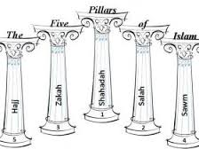

- 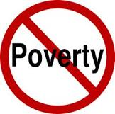Relative Poverty- Design a poster about the difference between relative poverty and those who are well off in Britain. On one half of the paper show what life would be like for someone living in relative poverty. Contrast this to the life of someone who is well off.

- Absolute Poverty- Imagine you are child living in ABSOLUTE poverty in Brazil. Write a letter to a friend telling them what life is like for you and how you feel about your situation. Include the following key words:

Absolute poverty education work family illness stress

- Christianity and Poverty- Investigate one of the following Christian charities; SCIAF, Mary’s Meals, Christian Aid.. Choose 1 project that one of these charities is currently focusing on. Write a summary about: WHY the charity was setup, why it is running this PARTICULAR project. 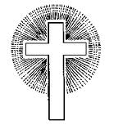

- 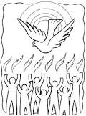Pentecost – Complete the story board below on the events that lead up to Pentecost. Explain the CHANGE in the disciples that occurred at Pentecost.

Jesus dies on Good Friday | Mary Magdalene tells the disciples Jesus has risen.

- Abortion- Investigate – some statistics on abortion in the UK last year. Find out: How many abortions were performed and the REASONS given for the abortion.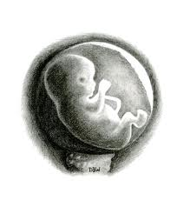
- Abortion- Your friend is 15 and she is pregnant. She does not know what to do and she is scared. What would you tell her to do? Write her a letter giving her advice. What do you think she should do and WHY do you think this.
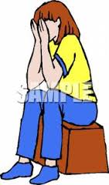

- Euthanasia- Find a story in the paper/internet about someone who is asking the government to allow them to die. Bring the story in and prepare 3 reasons in support of the persons argument and 3 against it.

- The Hospice- 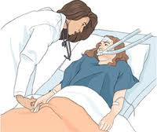
Imagine you are one of the following people working in a hospice; either a nurse, a chaplain, a cook. Write a diary entry about your job and how it benefits the patients in the hospice. Write how working in a hospice would be different form working in a hospital.

- 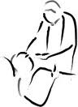Anointing of the Sick- You are dying. It is your last request that you speak to a priest and that he hears your confession. Write down the conversation that you and the priest might have. Tell him why it is so important to you that you receive the last rites.

- Anointing of the Sick- Read some of the words below which are taken from the last rites. Choose 2 phrases and explain what you think they MEAN and how they would HELP someone who is dying.
Extract From the Last Rites
Hear us, holy Lord Father, almighty everlasting God, and in your goodness send your holy angel from heaven to watch over and protect all who live in this home, to be with them and give them comfort and encouragement; through Christ our Lord.
May almighty God have mercy on you, forgive you your sins, and lead you to everlasting life. may the Lord forgive you all the evil you have done through the sense of taste and the power of speech.
Holy Lord, almighty Father, everlasting God, in pouring out the grace of your blessing on the bodies of the sick, you show your loving care for your creatures. And so now as we call on your holy name, come and free your servant from his (her) illness and restore him (her) to health; reach out your hand and raise him (her) up; strengthen him (her) by your might; protect him (her) by your power; and give him (her) back in all desired well-being to your holy Church; through Christ our Lord. Amen
. 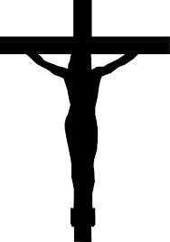

Phrase 1: _________________________________________________________________________________________________________________________________________________________________________________

Phrase 2:

Advent /Christmas Tasks:

- Imagine you are either Mary OR Joseph. Write a letter explaining either:
How you feel to be told that you are going to be the Mother Of God, what are your concerns?
OR: How you feel when Mary tells you that she is pregnant. How do you react? What worried you most about this situation?

- Find out about someone in today’s media who is a light shining in the darkness of some local, national, or international situation. Write a short summary about the situation and be prepared to tell the class about it.

- 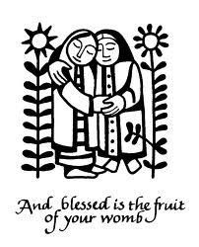The Visitation:
Fill in the spaces :
Mary went to visit her cousin E__________. Mary heard that her cousin was expecting her first b________ after many years of m___________ to Zechariah. Mary wanted to help her c___________. She also wanted to tell her about her own g_______ n________. Elizabeth told Mary that when she heard her voice the b________ in her w______ jumped for j___. She told Mary that she was b__________ among women. Elizabeth was proud that the mother of G______ had come to v________ her. Mary was so happy that she started to s_______. Mary stayed with her cousin for about three__________ until the baby was born. Elizabeth and Zechariah named their son J_______.

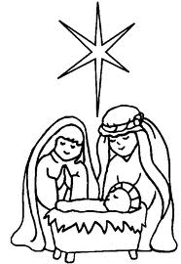The Nativity:

Imagine you are either Mary OR Joseph. Write a diary entry about the first Christmas where your son was born. Write about how you feel about his birth and what your hopes are for his future. What are you looking forward to most/ worried about?

The Rosary 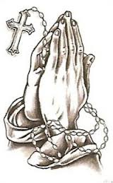

Look at the news/ other media this week. Think about the sorrowful mysteries and choose someone who is suffering. Write down what has happened to the person/ what the situation is. Report back to the class and we will say the rosary this week for all that person.

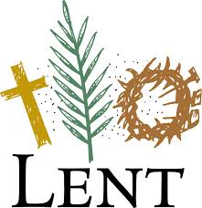 Lent:
Imagine you are Jesus alone in the desert. Write a postcard to a friend telling them about your trip. Describe why you went there and what was especially challenging about it.

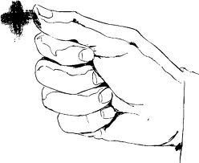Stations of the Cross.
Choose 1 station of the cross. Describe what is happening in the station and how you think Jesus must have been feeling at this time. Think about who else might have been involved; the crowds, the disciples, Mary. How would they have been feeling/ reacting?

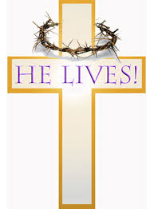Easter –The Resurrection

Imagine you are Mary Magdalene. Write a short diary entry explain how you felt on Easter Sunday. Eg going to the tomb, discovering Jesus was gone, when Jesus appears to her, going to tell the disciples. Think about the different emotions she would have felt on this day- which is the most important day in the history of the Church.

November - The Holy Souls.

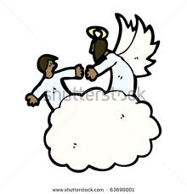 Look at the news/ media this week. Think about someone who has died who you do NOT KNOW. Write down the person’s name if you can, what happened to them and why you want to pray for them in particular. Eg maybe it was someone who had no family, or someone who led a bad life and who is really in need of prayers.

Imagine you are dead and in Purgatory. Write a short note to be posted to people back here on earth. Write about what it’s like being in Purgatory and why you want to go to Heaven so badly.

