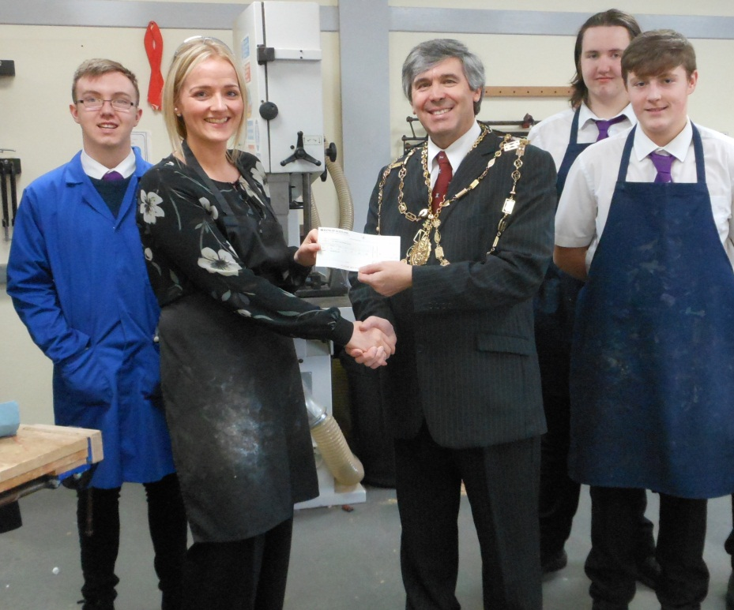

Senior Phase

Practical Metalworking

Miss Foulds’ Senior Phase practical metalwork pupils were visited by the Trades House Deacon Convenor after the departments recent success at the Trades House school competition. The Trades House were impressed by the quality of work being produced by the pupils within the department.

As the Design Technology Department have recently introduced the Metalwork course as an option for senior phase, the Deacon Convenor presented a cheque to help support the work being undertaken.

These funds will go towards further improvement of the workshop facilities and will support the current level of investment in the department. Pupils now have access to welding facilities within the department and this helps support the work required for their National level course

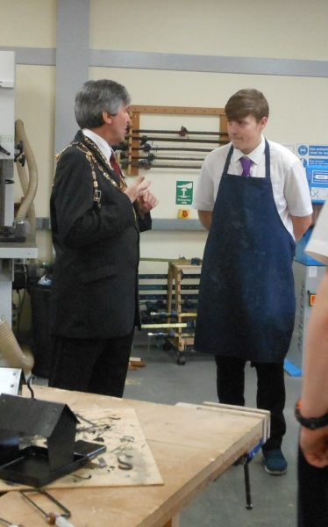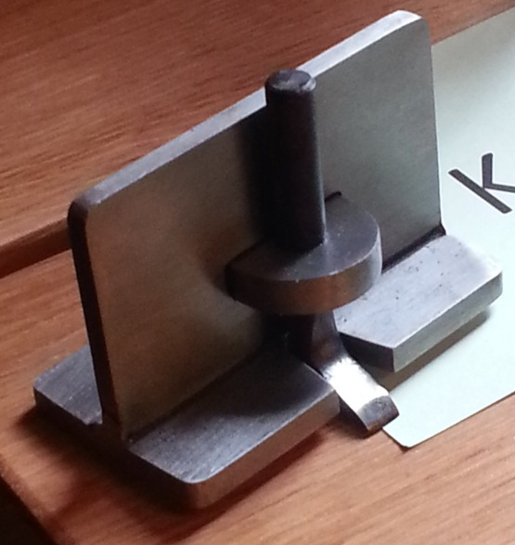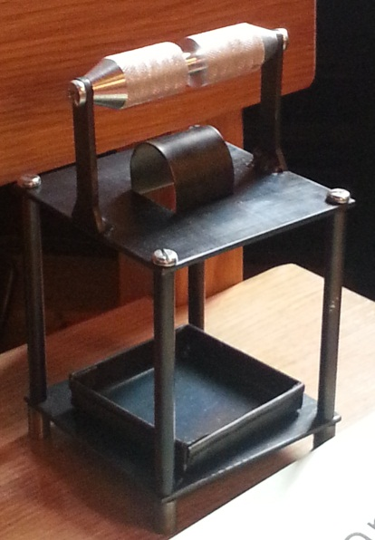

Some examples of projects that the class have manufactured are shown above: A Garden Lantern and a Hand Router.

Miss Foulds would like to thank all the pupils involved in show casing the good work of the department; they were a credit to themselves and the school.